Index

- Servers
- Serving JSON

Servers

First of all, let us remember that a client that makes a request to a server, which in turn sends a response, communicates with the same via protocols: predefined rules to establish communications through sockets, which are a kind of communication channel using TCP or UDP ports. Each TCP / IP application layer protocol performs a function: web information transmission, file transfer, email, etc.

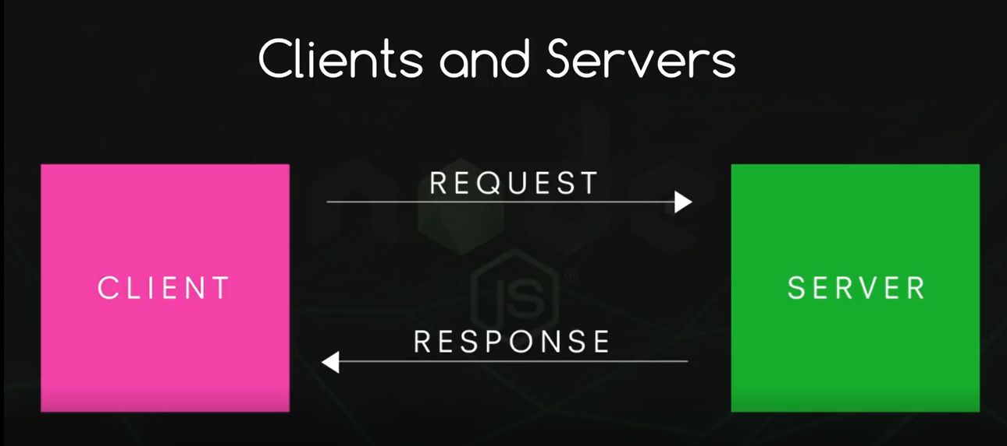
The extra information is sent through headers

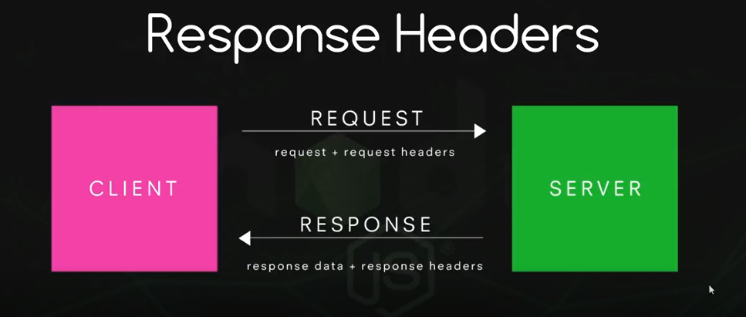
For example, in the response, the server tells the client the type of content it sends to know what to do with it, a browser will show the html information as a web page but a text or json file will not be shown. The status of the shipment also appears in the response headers: 200 if everything is correct, 404 error, etc.

In Node we can create http servers using the http module.

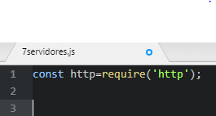
To create it we have the createServer method of this module, which takes as a parameter a function in turn with two parameters, one that stores the request made and the other the response.

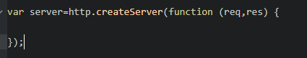

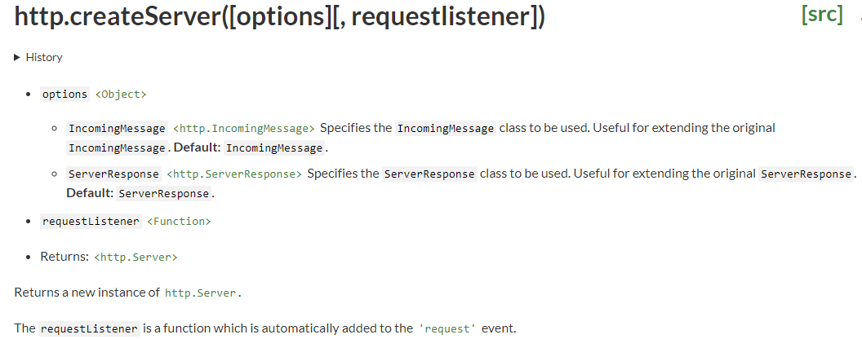
We are going to specify the response header where we will say that plain text is sent and create the plain text itself. It is also necessary to define a port and the IP, we will use 3000 and as the server that we create now is local 127.0.0.1.

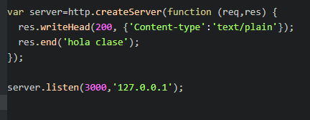

Now we go to a web browser and type

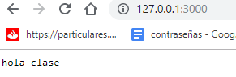
and if we right-click on the page, we can see the request in the network section

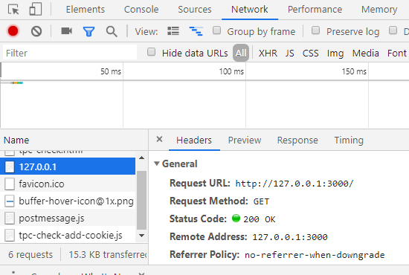
If we add any word or path after the port, we will still get the same answer from the same plain text. To see it better, we add a line to the createServer function to see the url that the request sends:

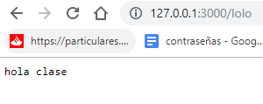
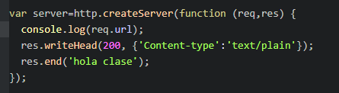
We will learn to control the response with different urls by routing.

- Serving JSON

Serve JSON to the client

JSON is a way of writing the data with javascript notation: https://www.w3schools.com/js/js_json_intro.asp

https://developer.mozilla.org/es/docs/Learn/JavaScript/Objects/JSON

It is widely used to send data between servers and clients. For this reason, we must learn how to send them from our node server.

The first thing is to change the type of data we send. We also create a simple JSON object and we can think of doing something like this

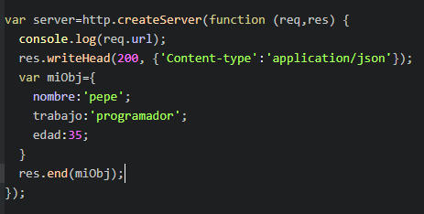
However, the end method takes a string or buffer as a parameter, and myObj is not. To fix this, we "stringify" it:

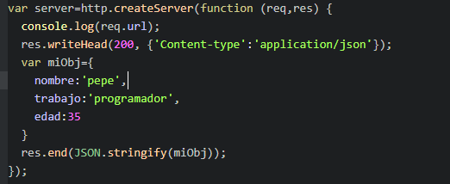
To convert a string to json we use JSON.parse (string).

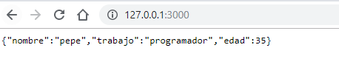
A JSON request can come from some javascript code that makes it, and then displays the data in a certain way on the front-end of a web page.

The usual thing is to work with JSON files. We can combine the asynchronous / synchronous modes that we saw earlier with the methods seen now.

To work with a JSON file:

Reading a JSON file:

Method 1: Using require method: The simplest method to read a JSON file is to require it in a node.js file using require() method.
Syntax:

const data = require('path/to/file/filename');
Example: Create a users.json file in the same directory where index.js file present. Add following data to the json file.

users.json file:

[
{
"name": "John",
"age": 21,
"language": ["JavaScript", "PHP", "Python"]
},
{
"name": "Smith",
"age": 25,
"language": ["PHP", "Go", "JavaScript"]
}
]
Now, add the following code to your index.js file.

index.js file:

// Requiring users file
const users = require("./users");

console.log(users);
Now, run the file using the command:

node index.js

Method 2: Using the fs module: We can also use node.js fs module to read a file. The fs module returns a file content in string format so we need to convert it into JSON format by using JSON.parse() in-built method.
Add the following code into your index.js file:
index.js file:

const fs = require("fs");

// Read users.json file
fs.readFile("users.json", function(err, data) {

// Check for errors
if (err) throw err;

// Converting to JSON
const users = JSON.parse(data);

console.log(users); // Print users
});
Now run the file again

Writing to a JSON file:

We can write data into a JSON file by using the node.js fs module. We can use writeFile method to write data into a file.

Syntax:

fs.writeFile("filename", data, callback);
Example: We will add a new user to the existing JSON file, we have created in the previous example. This task will be completed in three steps:

Read the file using one of the above methods.
Add the data using .push() method.
Write the new data to the file using JSON.stringify() method to convert data into string.

const fs = require("fs");

// STEP 1: Reading JSON file
const users = require("./users");

// Defining new user
let user = {
name: "New User",
age: 30,
language: ["PHP", "Go", "JavaScript"]
};

// STEP 2: Adding new data to users object
users.push(user);

// STEP 3: Writing to a file
fs.writeFile("users.json", JSON.stringify(users), err => {

// Checking for errors
if (err) throw err;

console.log("Done writing"); // Success
});
Run the file again

More about it:

https://blog.codingblocks.com/2018/reading-json-files-in-nodejs-require-vs-fs-readfile/

Exercise: Create a JSON file and with the help of this article show it on the server in the way you choose, commenting on some advantages and disadvantages.

Afterwards we could use the method get from the http module to create a client to make a request. Create this client and execute it as well to get the request:

let http = require('http')
let data = ""
let options = {
host: '127.0.0.1',
port: 3000,
path: '/'
}

let request = http.get(options, function (res) {
res.on('data', function (chunk) {
data += chunk
})
res.on('end', function () {
data = JSON.parse(data)
console.log(data)
})
res.on('error', function (e) {
console.log("There was an error: " + e.message)
})
})

More information:

https://nodejs.org/es/docs/guides/anatomy-of-an-http-transaction/

